**Community Preservation Fund Eligibility Form**

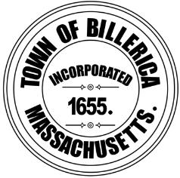TOWN OF BILLERICA

COMMUNITY PRESERVATION COMMITTEE

365 BOSTON ROAD, BILLERICA MA 01821

*The purpose of this form is to make sure that all project applications applying for Community Preservation Act funding are eligible for funding. This form must be approved in order for an application to be accepted.*

|  |  |  |  |
| --- | --- | --- | --- |
| Project Title: |  | | |
| Project Sponsor/Organization: |  | | |
| Contact Name: |  | | |
| Mailing Address: |  | | |
| Daytime phone #: |  | Fax #: |  |
| E-mail address: |  | | |
|  | | | |
| CPA Program Area (check those that apply):  Open Space  Historic Preservation  Community Housing  Recreation  Project Purpose (check those that apply):  Acquisition  Creation  Preservation  Support  Rehabilitation/Restoration | | | |
| Project Summary: Please provide a brief description of the project. | | | |
|  | | | |
| For CPC Use  Eligible  Not Eligible Date: __________ Reviewer:____________________ | | | |

COMPLETE AND SUBMIT THE PROJECT ELIGIBILITY FORM.

DO NOT PROCEED UNTIL ELIGIBILITY HAS BEEN DETERMINED.